Salesforce CRM Capstone Project:
HandsMen Threads: Elevating the Art of
Sophistication in Men's Fashion

by

Jan Jan Mañibo Garcia
BSIT 4-1

Polytechnic University of the Philippines
Bansud Campus
HandsMen Threads: Elevating the Art of
Sophistication in Men's Fashion

Project Overview
The HandsMen Threads Salesforce CRM project is developed to centralize all essential business operations, including customer management, product tracking, order processing, inventory monitoring, and marketing coordination. This system ensures smooth and organized workflow by connecting key business modules into a single CRM platform. It improves overall business efficiency by supporting accurate data management, quick decision-making, and seamless coordination among different departments such as Sales, Inventory, and Marketing.

Objectives
The main objective of the HandsMen Threads CRM project is to build a scalable and structured Salesforce application that will enhance customer interaction, streamline order processing, automate essential business operations, and maintain accurate inventory tracking. This CRM aims to support business teams through secure access, optimized workflows, and proper data handling. By using structured object relationships, validation rules, and automation, the system will help HandsMen Threads achieve improved operational efficiency and customer satisfaction.

Phase 1: Requirement Analysis & Planning
Understanding Business Requirements
- Manage customer information including contact details, email, phone number, and loyalty status.
- Track product details, stock levels, SKU codes, pricing, and inventory availability.
- Process and manage customer orders with accurate order amounts and product selection.
- Organize marketing campaigns and associate them with customers.
- Implement secure and role-based access for Sales, Inventory, and Marketing users.
Defining Project Scope and Objectives
- Create five essential custom objects: Customer, Product, Order, Inventory, and Marketing Campaign.
- Build object relationships to ensure accurate and connected data flow.
- Implement validation rules for accurate inputs and data integrity.
- Configure security using profiles, roles, and permission sets.
- Prepare email templates for communication and notification processes.
Design Data Model and Security Model
- Lookup and Master-Detail relationships between Customers → Orders → Products.
- Master-Detail relationship between Product and Inventory for stock tracking.
- Use profiles, roles, and permission sets for access control.
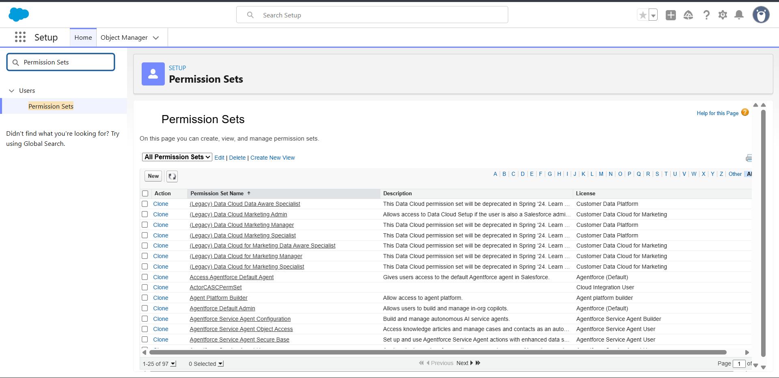

Stakeholder Mapping
- CEO – Oversees overall operations.
- Sales Team – Manages customers and orders.
- Inventory Team – Manages product information and stock.
- Marketing Team – Manages campaigns and customer engagement.
Execution RoadMap
- Environment Setup
- Object & Field Creation
- App & UI Configuration
- Security Setup
- Validation Rules & Automation
- Testing & Deployment
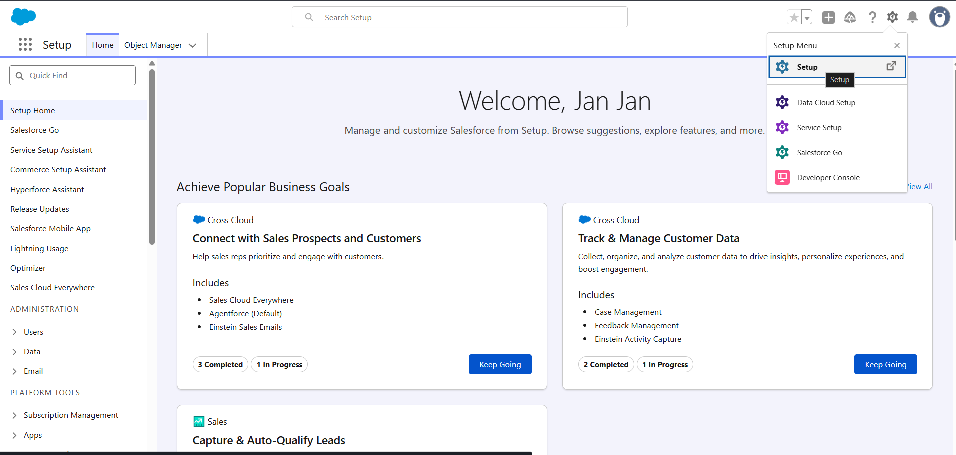
Phase 2: Salesforce Development – Backend & Configurations
Setup Environment
- Salesforce Developer Edition environment created.
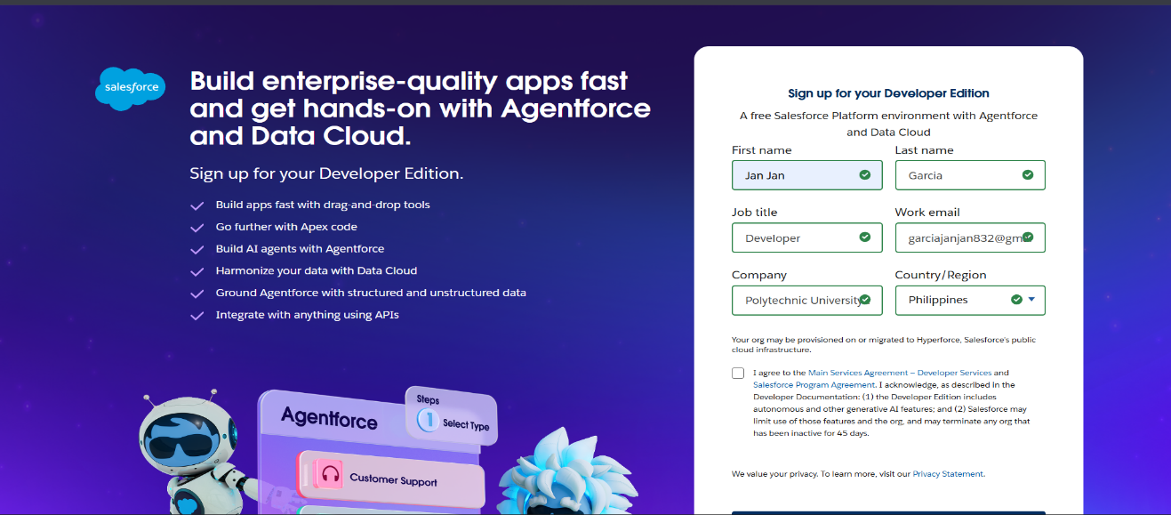
- Basic organization settings configured as needed.

Customization of Objects, Fields & Tabs
Custom Objects Created
- Handsman Customer
- Handsman Product
- Handsman Order
- Inventory
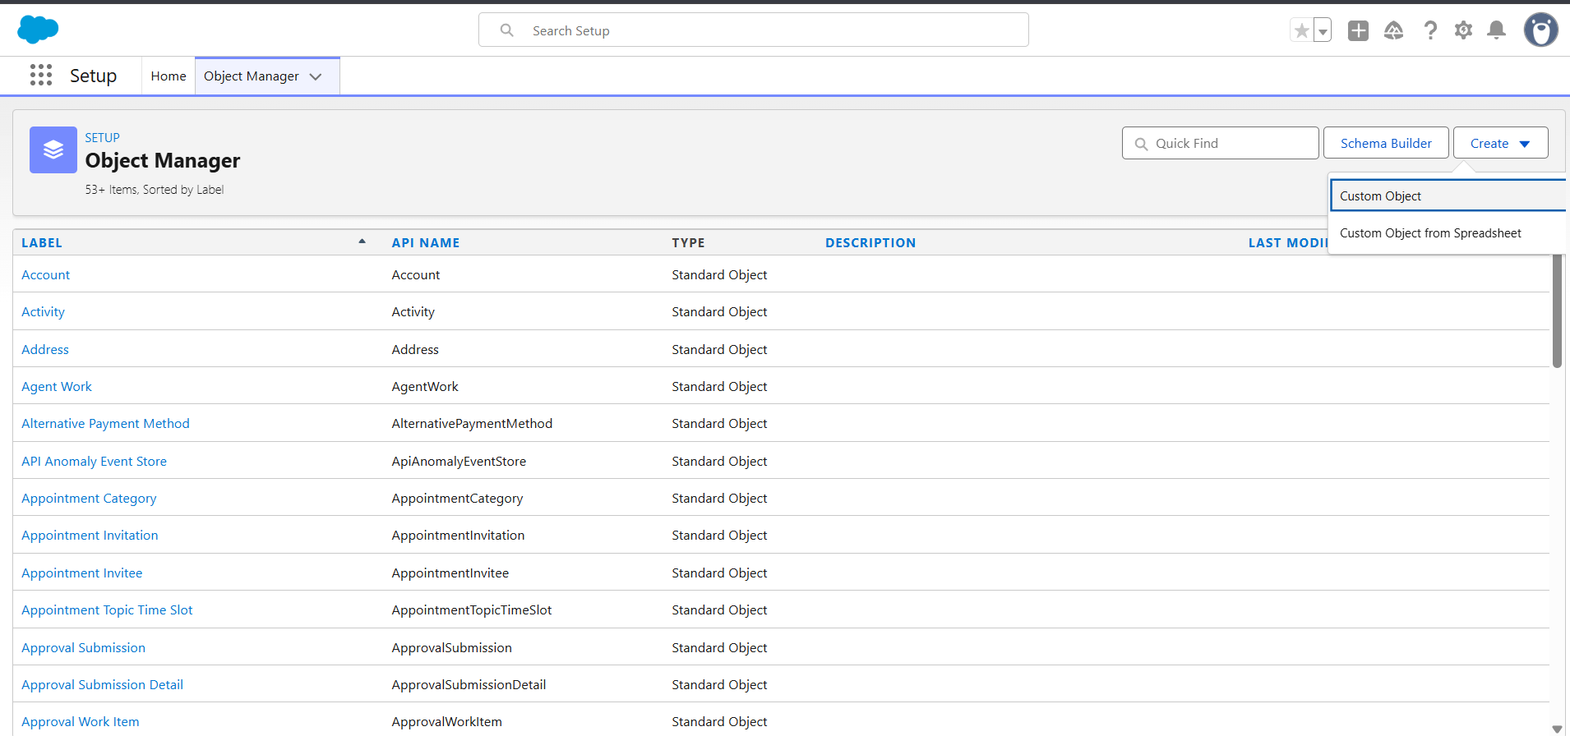
- Marketing Campaign

Custom Tabs Created
- Tabs created for all custom objects for easy navigation.
Custom Fields
Examples include:
- Customer: Email, Phone, Loyalty Status, Full Name (Formula)
- Product: SKU, Price, Stock Quantity
- Order: Total Amount, Order Date
- Inventory: Stock Status (Formula), Restock Needed
Object Relationships
- Customer → Order (Lookup)
- Product → Inventory (Master-Detail)
- Order → Product (Lookup)
Formula Fields
- Full Name (Customer)
- Stock alert flow (Inventory)
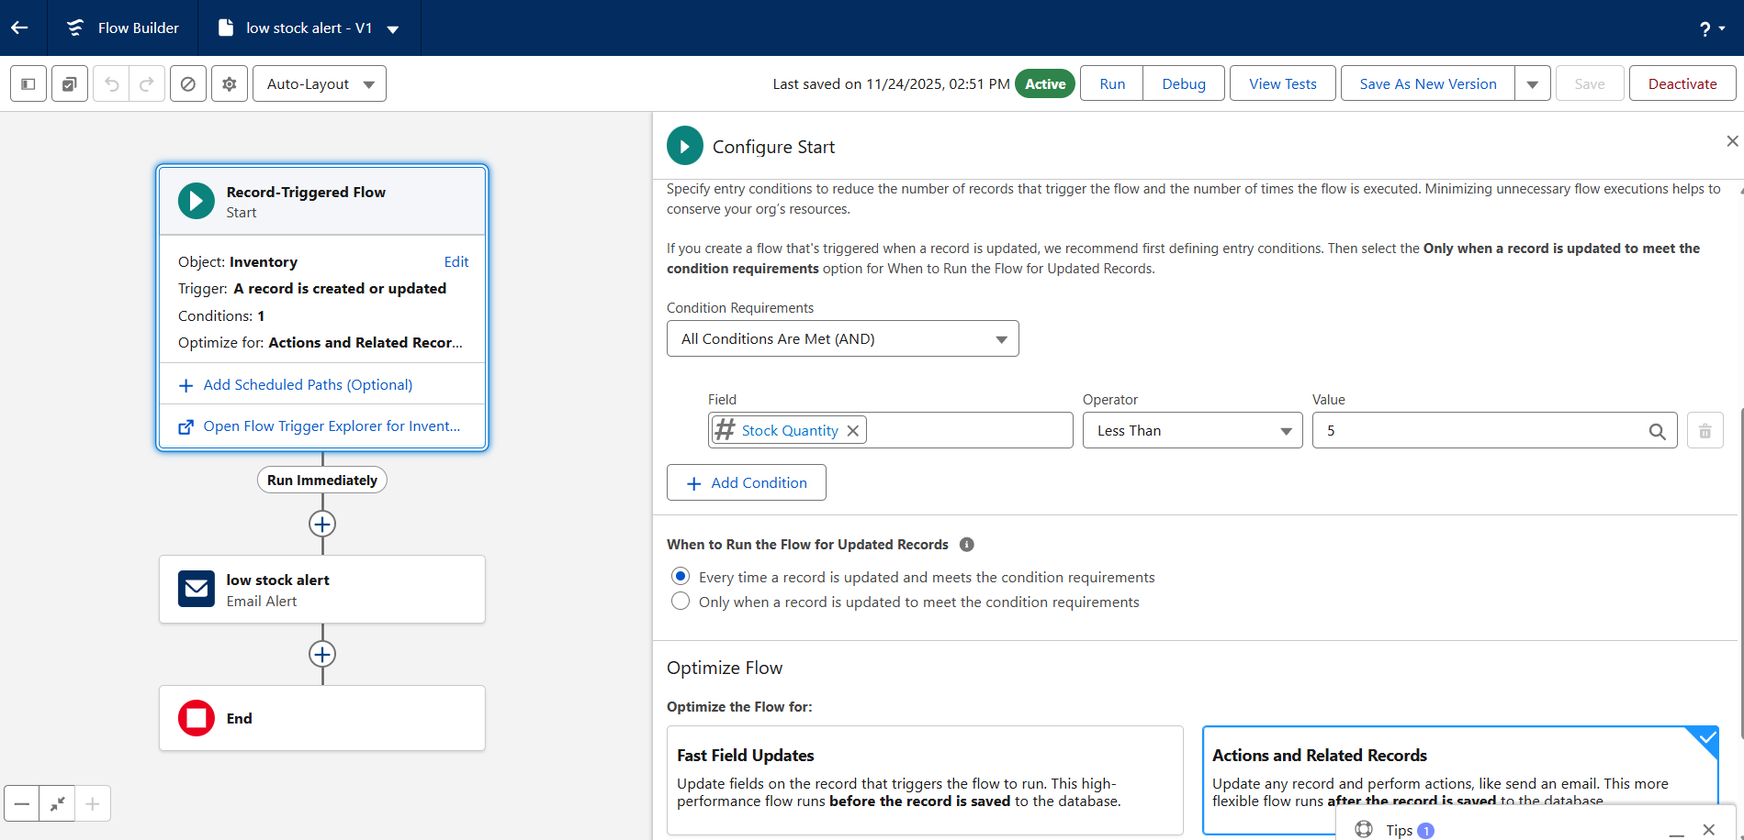
  - Automatically shows “Low Stock”, “In Stock”, or “Out of Stock”.
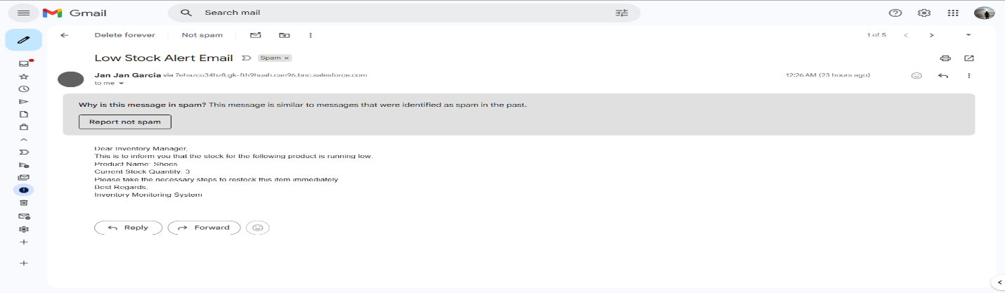
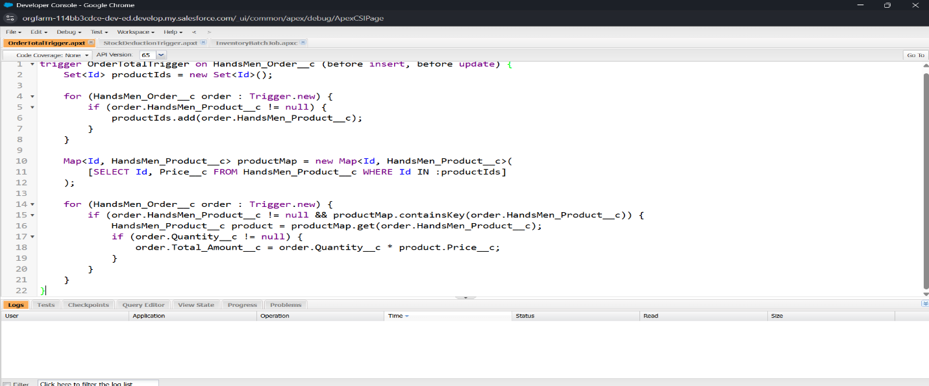

- Scheduled Flow: Loyalty Update Alert (Inventory)
- Loops through customers and updates their loyalty status based from the customer’s total purchase.
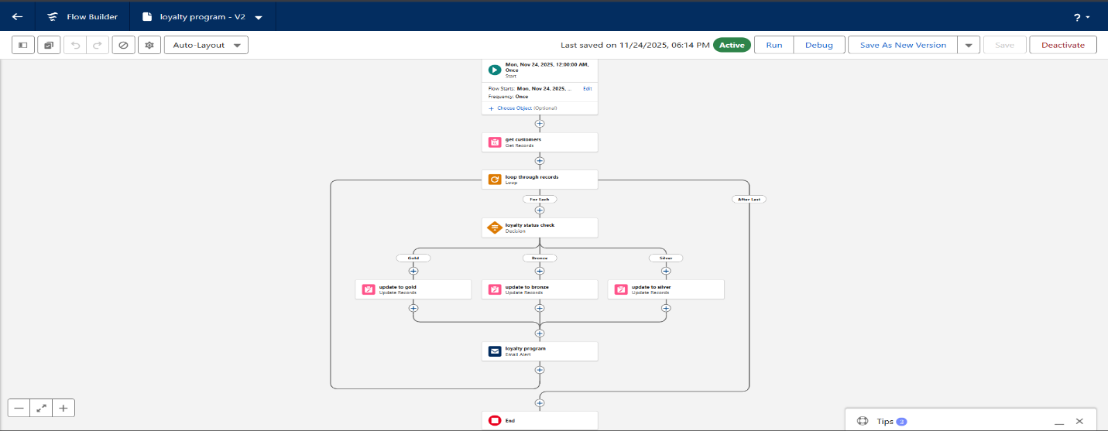
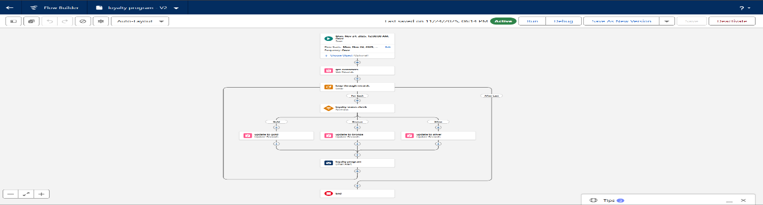
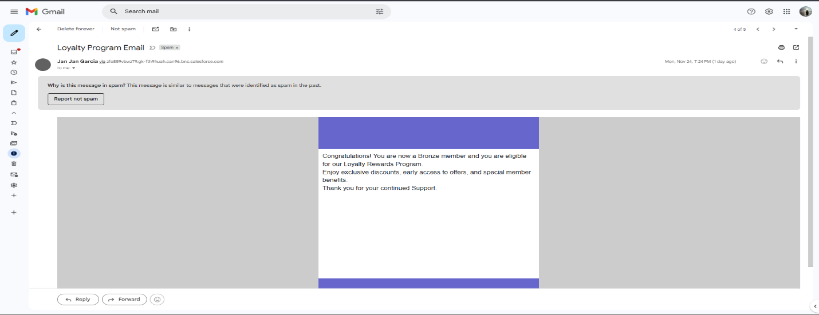

- Order Confirmation Flow
- Triggered when an order is updated to Confirmed.
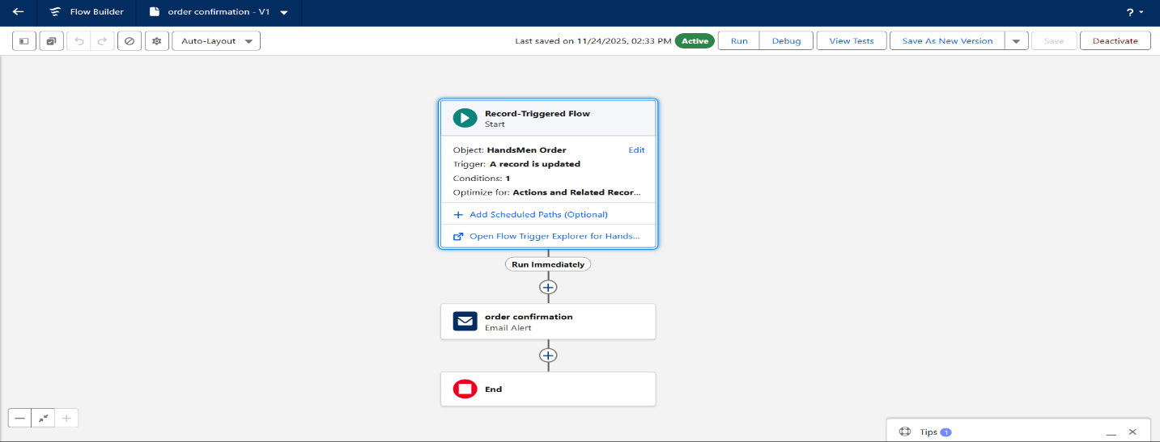
- Sends an Order Confirmation email to the related customer.
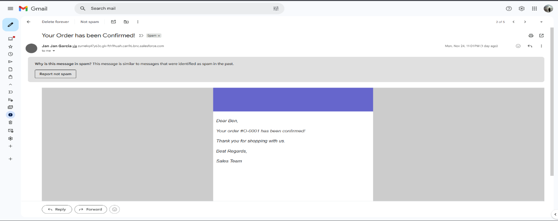

Validation Rules
- Prevent negative stock values.
- Ensure valid email format.
- Enforce positive order total.
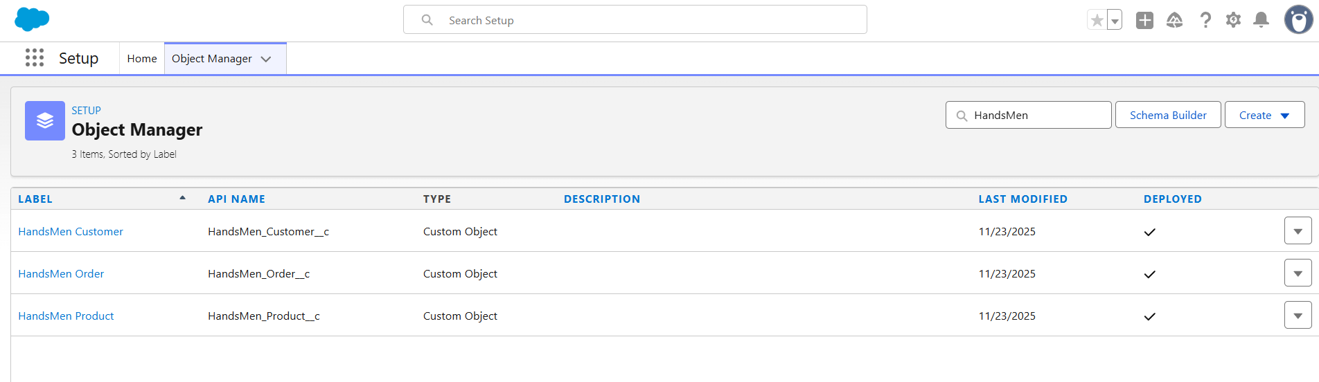
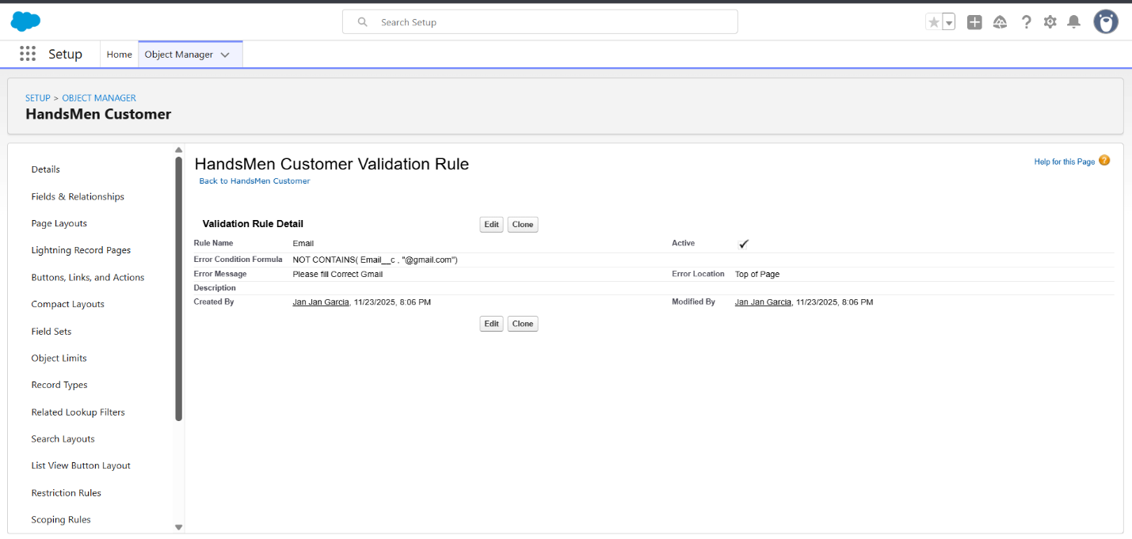
- Ensure required fields are filled.

Phase 3: UI/UX Development & Customization
Lightning App Setup
- App Name: HandsMen Threads
- Added:
  - Custom Objects
  - Standard items
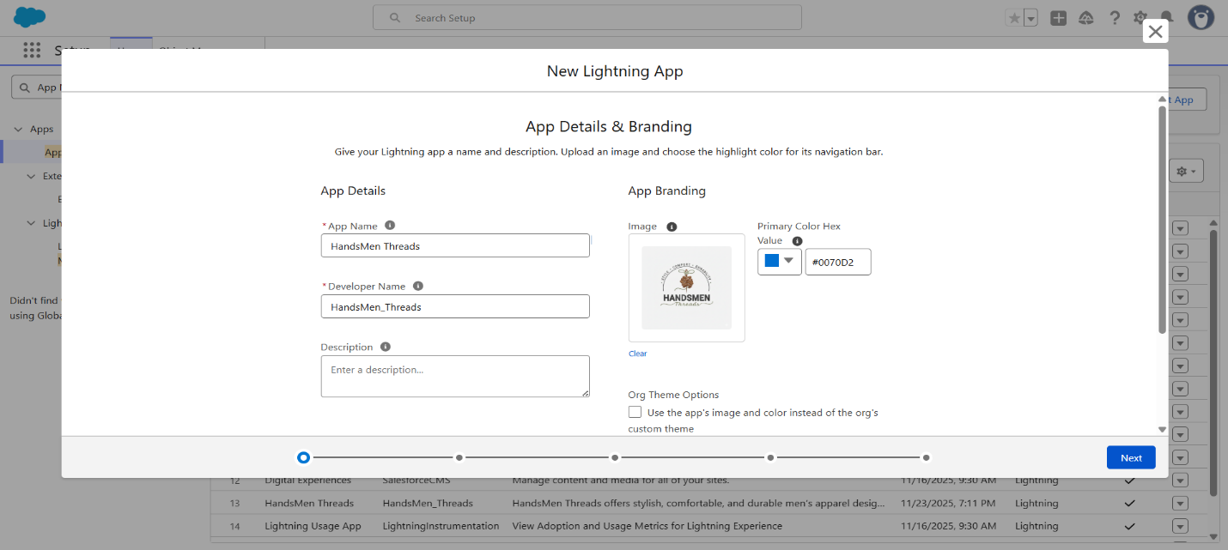
  - Navigation items for relevant teams
Page Layouts & Dynamic Forms
- Sections created for customer details, product data, order information, and inventory tracking.
User Management
- Profiles cloned and customized.
- Roles created:
  - CEO
  - Sales
  - Inventory
  - Marketing
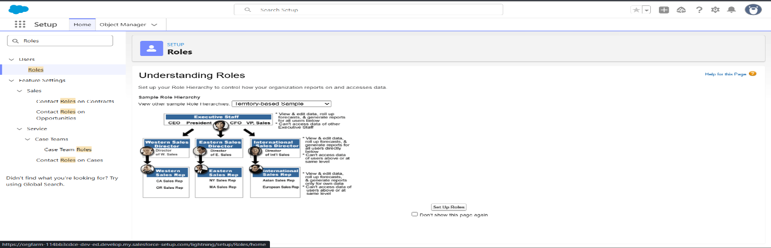
- Users created and assigned to their respective roles.

Phase 4: Data Migration, Testing & Security
Data Loading
- Manual record entry shown in the video.
- For large-scale import, Data Loader or Import Wizard may be used.
Field History Tracking
Recommended for:
- Stock Quantity
- Product Price
- Customer Contact Information
Duplicate & Matching Rules
- Email-based matching for Customer
- SKU-based matching for Product
Profiles, Roles & Permission Sets
Profiles
- Customized profiles for Sales, Inventory, and Marketing.
Roles
- Sales → CEO
- Inventory → CEO
- Marketing → CEO
Permission Sets
Examples:
- Sales: Full access to Customers and Orders
- Inventory: Read/Edit access to Products and Inventory
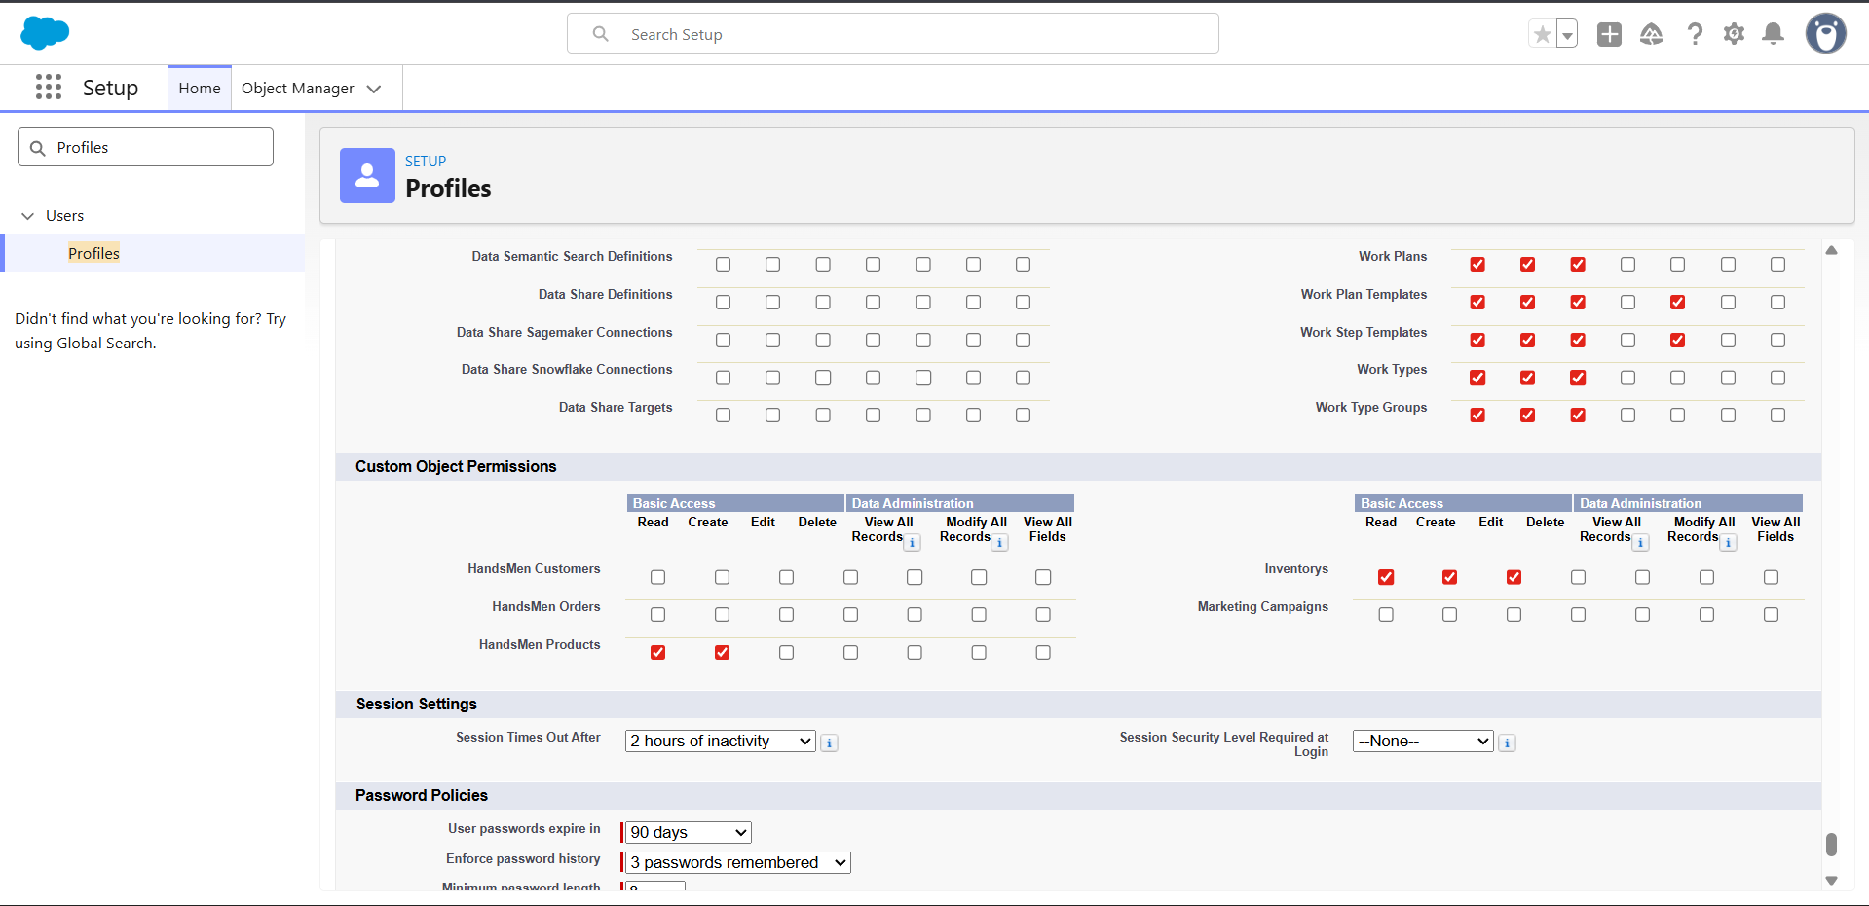
- Marketing: Access to Campaigns

Test Cases
Examples include:
- Customer creation (valid/invalid email).
- Order creation with total amount validation.
- Product creation with required field checks.
- Inventory stock status formula test.
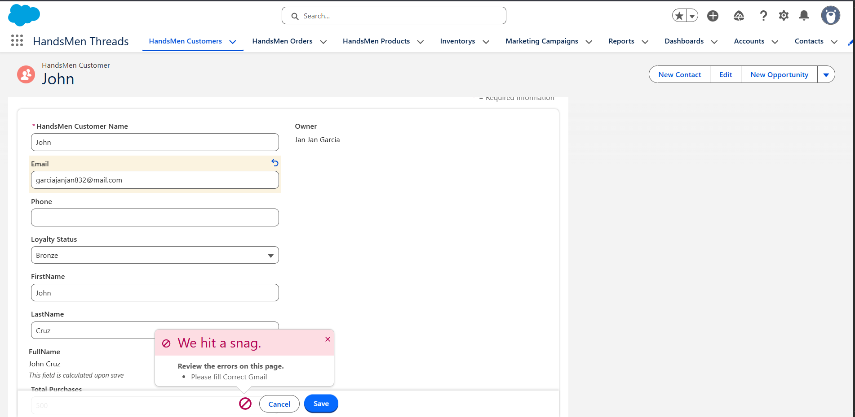

Phase 5: Deployment, Documentation & Maintenance
Deployment Strategy
- Change Sets recommended for migrating components into a production environment.
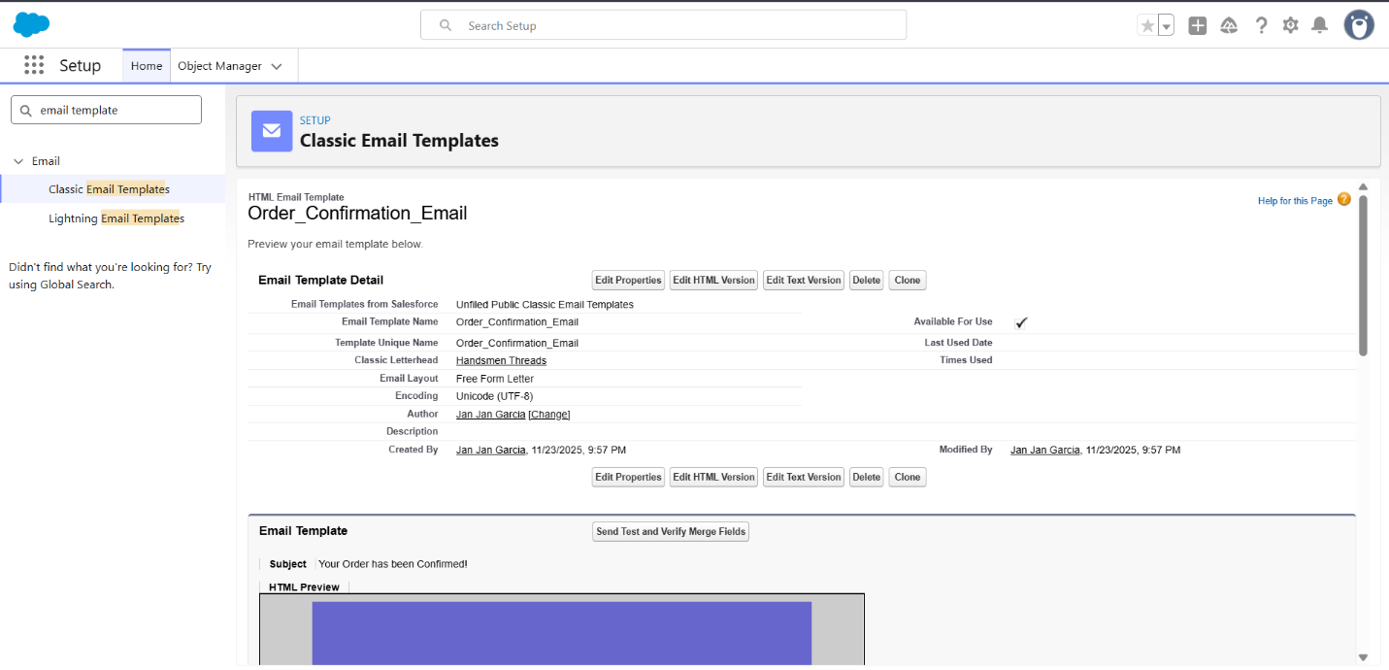
- Includes: Objects, Fields, Validation Rules, Profiles, Roles, Permission Sets, Email Templates.
Maintenance
- Regular updates for inventory fields.
- Role and profile audits.
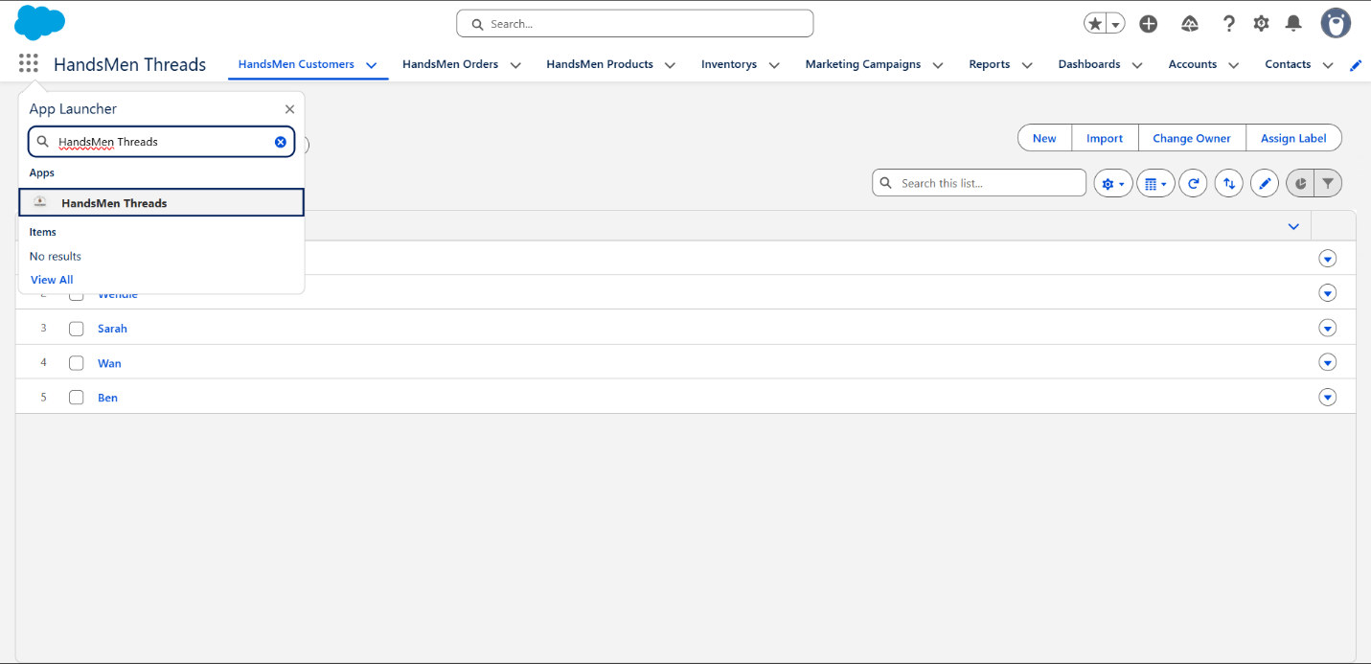
- Ongoing validation rule monitoring.

Troubleshooting
- Debug Logs for tracking automation errors.
- Field-level history for identifying incorrect updates.
- Permission checks for access issues.

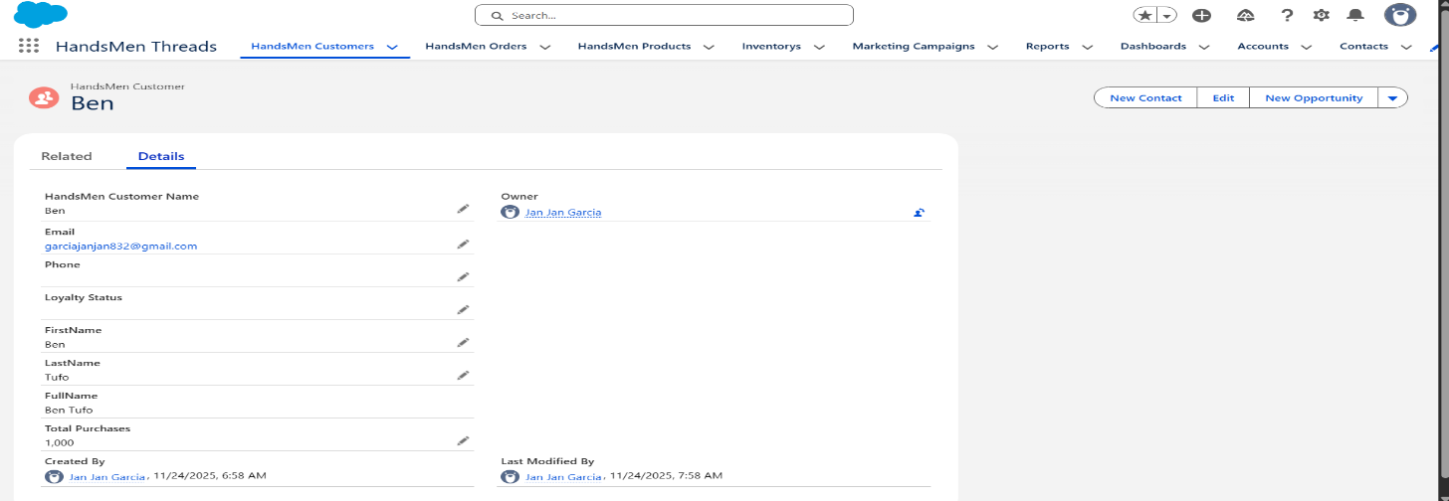
SCREENSHOTS
Fig: Custom App for HandsMen Threads
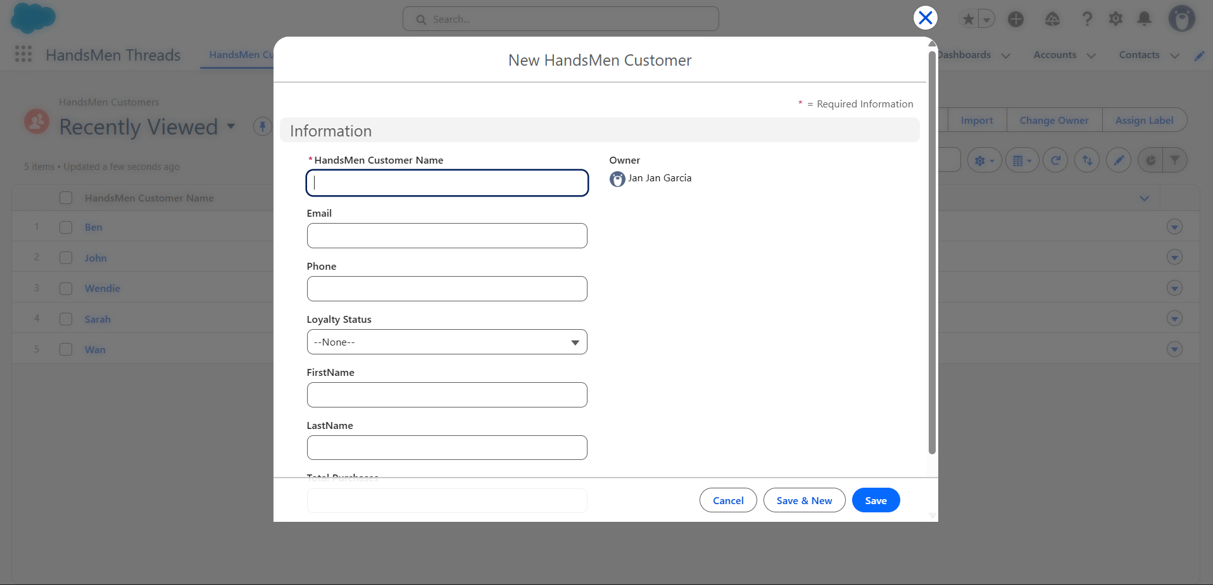
Fig: Creation of a New HandsMen Customer

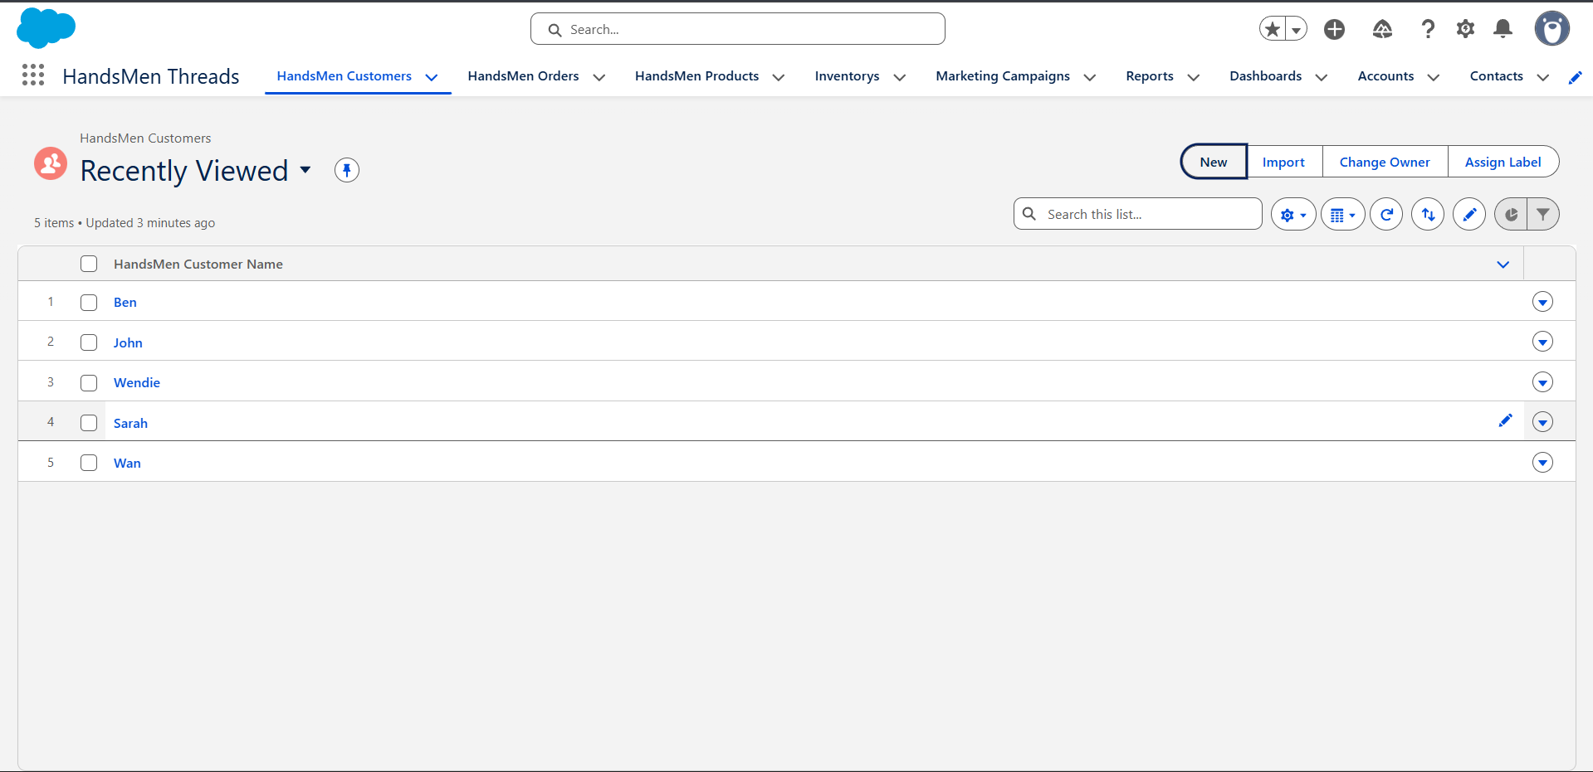
Fig: HandsMen Customer Name Page

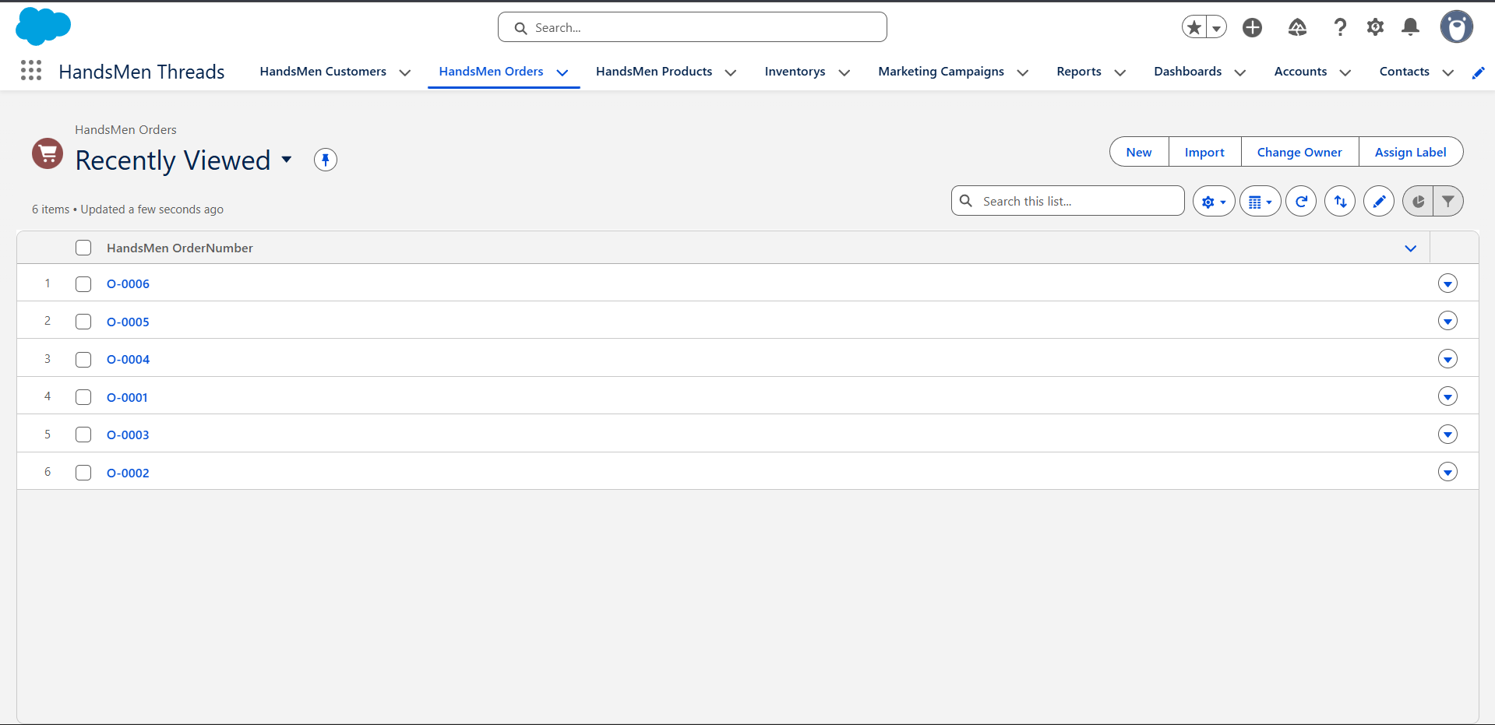
Fig: HandsMen Orders Page
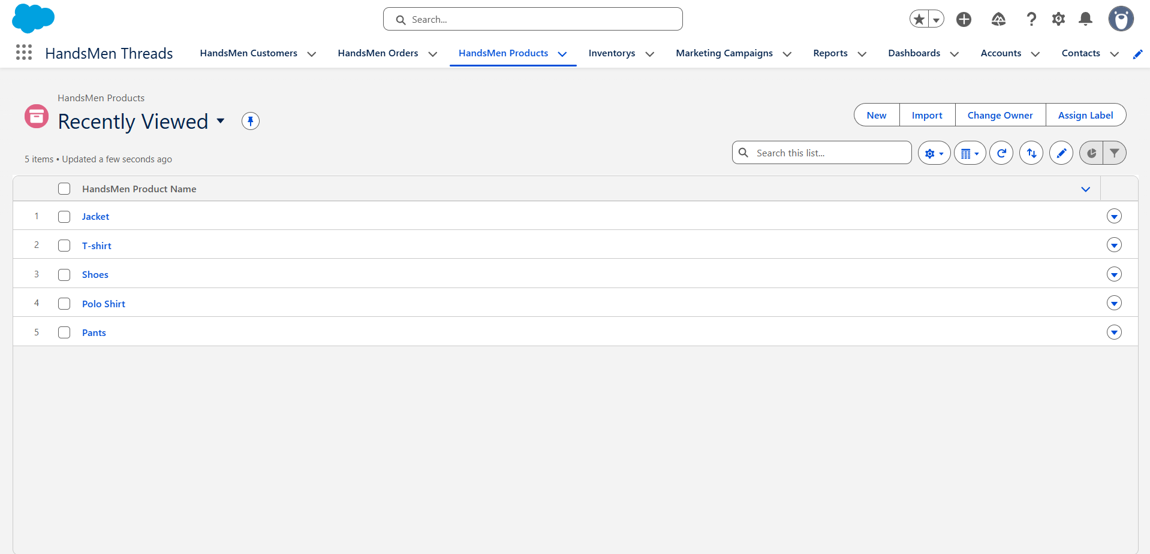
Fig: HandsMen Products Page

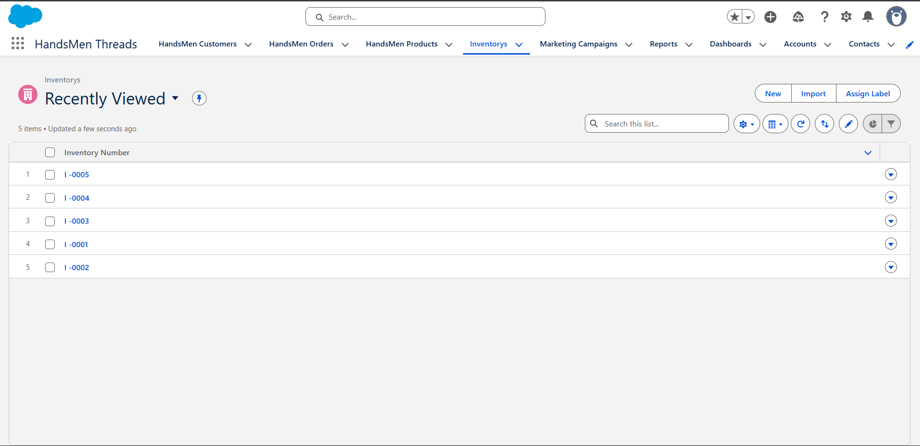
Fig: HandsMen Inventorys Page
Conclusion
The HandsMen Threads Salesforce CRM project integrates essential business processes such as customer management, sales tracking, inventory control, and marketing administration into a single streamlined platform. Through the use of custom objects, relationships, validation rules, and a secure role-based model, the system significantly enhances operational efficiency and ensures accurate information flow. This project strengthens the foundation for future enhancements including automation flows, approval processes, email automation, dashboards, and AI-based recommendations.

